Blake Parquette
Research Paper/ Lesson Plans
Soil Ecology EEES 5250, Spring 2013
April 26, 2013

Abstract
Soils possess a unique set of chemical and physical properties that are important in identifying and understanding interactions between the lithosphere, atmosphere, hydrosphere and biosphere. They also play a vital role in determining anthropogenic uses. The properties of texture and porosity will be investigated using hands-on and minds-on activities. In this activity, soil textures of different soil types will be classified. The soil texture ratios of soil samples will be determined and the porosity of each sample will be determined. Students will then compare the porosity to soil texture

Classroom Background Information
Subject | Science
Grade Level | 7
Class Period Length | 43 minutes
# Students/ Class | 17-28 students
Unit Topic | Water Cycle

Lesson 1: Physical Properties of Soil
Essential Question
How does soil permeability vary with soil composition?
Lesson Rationale
Soils vary in their composition of different size particles. This characteristic determines the water holding capacity of the soil.
Ohio Content Standards
Model Curriculum Grade 7 | Earth and Space Science (ESS)
Topic | Cycles and Patterns of Earth and Moon
Content Statement | The hydrologic cycle illustrates the changing states of water as it moves through the lithosphere, biosphere, hydrosphere, and atmosphere.
Ohio Department of Education. Ohio Revised Science Standards and Model Curriculum Grades K through Eight, Columbus, Ohio. Available at:
http://www.ode.state.oh.us/GD/Templates/Pages/ODE/ODEPrimary.aspx?page=2&TopicID=1705&TopicRelationID=1705

Student Learning Objectives
Each student will be able to:
- Classify soil texture by particle size
- Determine the soil texture ratio of an unidentified soil
- Measure the porosity of a soil sample
- Compare the porosity to the soil texture of a soil sample
Key Terminology
- porosity/pores
- permeability
- texture
- soil texture triangle
- soil types (clay, sand, silt)
Planned Assessments
- Formative Assessments: introductory reading quiz; lab questions
- Summative Assessment: end of lesson quiz
Resources
Per Lab Group (2-3 students):
- soil texture triangle
- known soil samples (clay, silt, sand)
- 100 ml graduated cylinder
- tap water
- hand lens
- unknown soil sample –brought from home
- mason jar w/lid
- powdered dishwashing detergent
- calculator
- colander
- cookie sheet
- measuring cup (1-cup)
- 250 ml beaker
- paper towels
- metric ruler
Per Student:
- introductory reading “Topic 6: Properties of Soils” http://www.soil-net.com/primary/ks2/topic6/topic6_factsheet.pdf & “Fact Sheet: Soil Types” http://www.soil-net.com/sm3objects/activities/Factsheet_SoilTypes1.pdf
National Soil Research Institute (NSRI); Cranfield University, 2013. http://www.soil-net.com.
- formative assessment: “Formative Assessment #1”
- lab worksheet “Physical Properties of Soil”
- summative assessment “ Physical Properties of Soils”
Lesson Agenda
Day 1
1. Background Reading : “Topic 6: Properties of Soils”, “Fact Sheet: Soil Types” (see attached)
- Assign Reading and Cornell Note talking
- Give written Formative Assessment #1 over content (see attached)
  - Think-Pair-Share: Have students respond individually, then share answers with partners, then discuss as whole group
2. “Physical Properties of Soil” lab activity (see attached)
- Randomly assign lab groups of 2-3 students
- Students will complete Part A
Day 2
1. “Physical Properties of Soil” lab activity
- Students will complete Part B, through Procedure Step 6
Day 3
1. “Physical Properties of Soil” lab activity
- Students will complete Part B
Days 4 and 5
1. “Physical Properties of Soil” lab activity
- Students will complete Part C
Day 6
1. Summative Assessment and Closure
- Students will complete a written summative assessment (see attached)
- Closure activity: Discussion of different landscapes within Oak Openings Region and the role of soil texture and porosity on the low water table in oak savannahs & the high water table in the wet prairies.

Enrichment
Design an alternative way of determining the porosity of a soil sample.
Reflection
References
Cahilly, W. (2000). Healthy soil starts with the right proportion of sand, silt, and clay. Fine Gardening, No. 72, pp. 67-69

Feather Jr., Ralph M., Snyder, Susan L., Zike, Dinah; The Changing Surface of the Earth; Glencoe/McGraw–Hill. 2005, pp. 42-49

Laboratory Challenge 13: What are some physical and chemical properties of soil? pp. 49-50; Concepts and Challenges in Earth Science, 3rd Edition. Globe Book Company, Englewood Cliffs, New Jersey, 1991

Laboratory Challenge 24: How do pore space and porosity affect the movement of water through soil? pp. 73-76; Concepts and Challenges in Earth Science, 3rd Edition. Globe Book Company, Englewood Cliffs, New Jersey, 1991

McDougal Little Science, Earth’s Surface, McDougal Little, 2005, pp. 128-131

National Soil Research Institute (NSRI); Cranfield University, 2013. http://www.soil-net.com.

Soil Studies Lab. National Environmental Education Foundation, Washington D.C., 2008-2012

Virginia Department of Education, Science Enhanced Scope and Sequence – Earth Science; Permeability and Porosity, 2012. http://www.doe.virginia.gov/testing/sol/standards_docs/science/2010/lesson_plans/earth_sci/earth_space_sys/sess_ES-8c.pdf

Handouts

- Pages 6-7 Topic 6: Properties of Soil
- Page 8 Fact Sheet: Soil Types
- Page 9 Formative Assessment #1
- Page 10 Formative Assessment #1 –Answer Key
- Pages 11-16 Lab Activity: Physical Properties of Soil
- Pages 17-18 Summative Assessment: Physical Properties of Soil
- Pages 19-20 Summative Assessment: Physical Properties of Soil – Answer Key

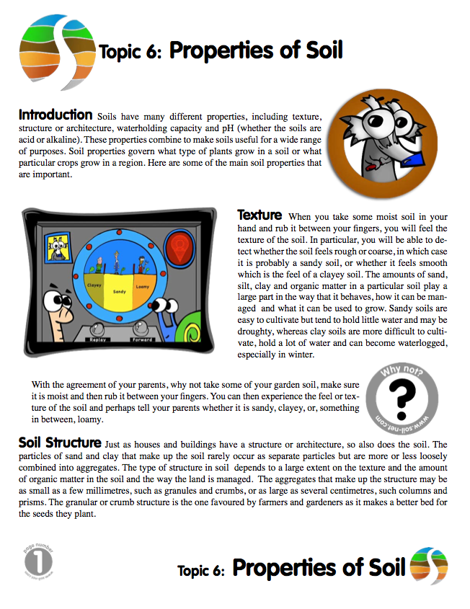

http://www.soil-net.com/primary/ks2/topic6/topic6_factsheet.pdf

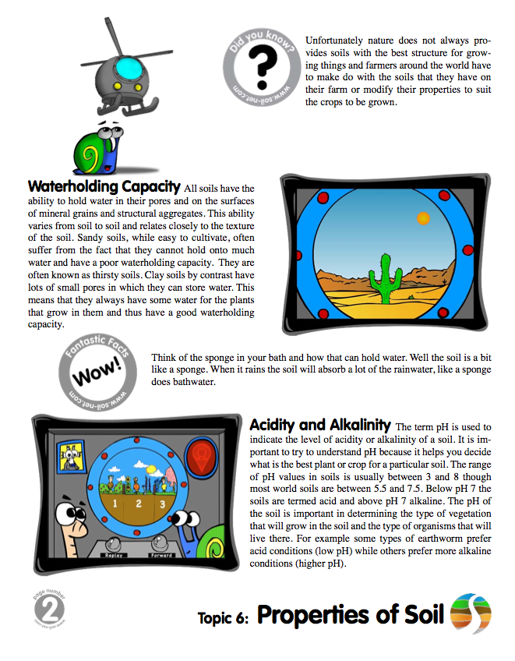
http://www.soil-net.com/primary/ks2/topic6/topic6_factsheet.pdf
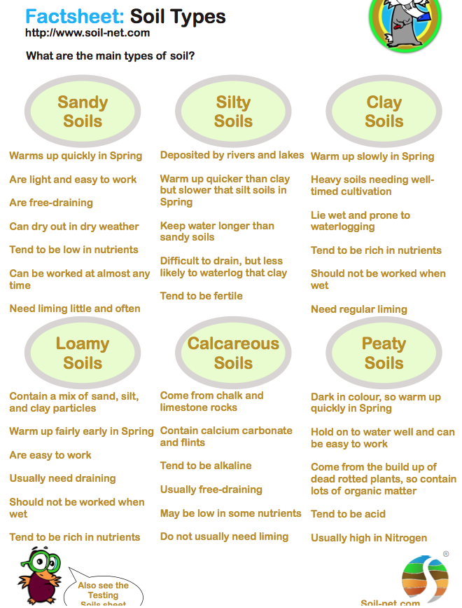

http://www.soil-net.com/sm3objects/activities/Factsheet_SoilTypes1.pdf
Formative Assessment #1 Properties of Soil
Name/Period: __________________________________
Directions: Use your Cornell notes that you created for the reading described below to answer the following questions.

Topic 6: Properties of Soil
http://www.soil-net.com/primary/ks2/topic6/topic6_factsheet.pdf

1) List 4 properties of soils

2) True or False… Soil properties are a main factor in determining which crops can be grown in particular regions.

3) Complete the following table:

Soil Type | Feels… | Ease of cultivation … | Water holding capacity
Sandy
Clayey

4) What term is used to describe the intermediate category of texture between sandy and clayey?

5) Fill in the blank: Soils rarely occur as separate particles, but rather are loosely combined into ____________.

6) List two factors that the type of soil structure is dependent upon:

7) What are the soil structures that hold water called?

8) True or False… Sandy soils can hold more water than clayey soils.
Lab Activity: Physical Properties of Soil Name/Period: ___________________

A. Classification of Soil Textures

Background Information
Soil texture is the way a soil feels and is a measure of the relative proportions of the different particle sizes, sand, silt, and clay. Sand is the greatest particle size (0.2 – 2.0 mm) and feels gritty to the touch. Silt is medium sized (0.002 – 0.2 mm) and feels soft and smooth. Clay is the smallest particle size (<0.002 mm) and feels sticky.

Materials
- hand lens
- paper towel
- known pure soil samples (clay, silt, sand)

Procedure
1. Place each soil sample on a separate sheet of paper towel. Using your fingertips and the hand lens, examine the three known soil samples and describe the particles in the spaces provided

sand: ____________________________________________________________
silt: ______________________________________________________________
clay: _____________________________________________________________

2. In Data Table #1, assign a number to each soil texture based on its particle size. The material with the smallest particles will be number 1. The material with the largest particles will be number 3.

3. Which of the three materials appears to have the largest pores, or spaces between particles? The smallest? In Data Table #1, assign a number to each soil texture based on the pore size between the particles. Assign the number 1 to the material with the smallest pores. For the material with medium-size pores, assign the number 2. Assign number 3 to the material with the largest pores.

Data Table #1: Particle and Pore Size
Soil Material | Particle Size | Pore Size
Sand
Clay
Silt

B. Identifying Soil Type

Background Information
Most soils are actually a mixture of the three particle types. The relative proportions of sand, silt, and clay determine the ability of the soil to retain water and nutrients.

Materials
- unknown soil sample
- paper towel
- cookie tray
- colander
- measuring cup
- 100 ml graduated cylinder
- powdered dishwashing detergent
- mason jar w/ lid
- metric ruler
- calculator
- soil texture triangle

Procedure
1. The unknown soil sample brought from home (by a group member) is spread out on a cookie tray for 1-2 days. ***DONE AHEAD of TIME***
2. Sift the soil sample through the colander to remove stones and large plant material.
3. Place one cup of the unknown soil sample into the glass mason jar.
4. Using the graduated cylinder, measure out 5 mL of powdered dishwashing detergent and add to the mason jar.
5. Fill the jar to the top with tap water, screw on the jar lid and vigorously shake for 3 minutes, thoroughly mixing the detergent, soil, and water.
6. Let the mixture settle for a 24-hour period. Three distinctive layers will settle. After about a minute, the coarse sand particles will settle into a layer on the bottom of the jar. Sand is the densest of the three particle types. The
next densest particle, silt, will settle out after about an hour. Silt is typically darker in color than sand. Fine textured clay will settle out of solution after approximately a day, forming the top layer. Clays are typically light in color.
-----------------------------------------------------STOP --------------------------------------------------------

7. In the space provided below, draw and label the 3 layers with the soil type.
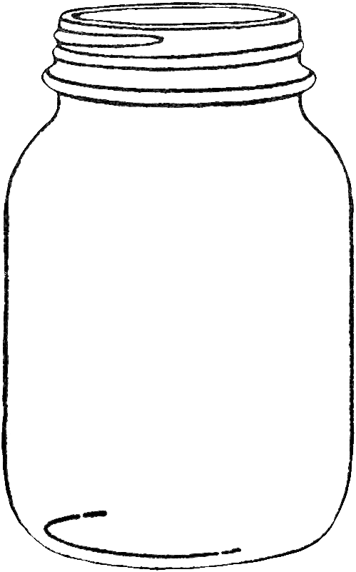

8. Calculate the percentages of sand, silt, and clay in the sample. To accomplish this first measure the total depth (in cm) of the soil layers. This measurement represents 100 percent of the soil sample. To figure out the percentages of each layer measure the depth of that layer and divide by the amount of the total sample. Record your calculations in Data Table #2.

Example: if …sand layer depth = 2cm
if …total depth (all 3 layers) = 4cm
then …sand layer depth / total depth = 2/4 = 50%

Data Table #2: Percentages of Soil Components
Material | Sand | Silt | Clay
Depth (cm)
Total Soil Depth (cm)
Percentage (%)

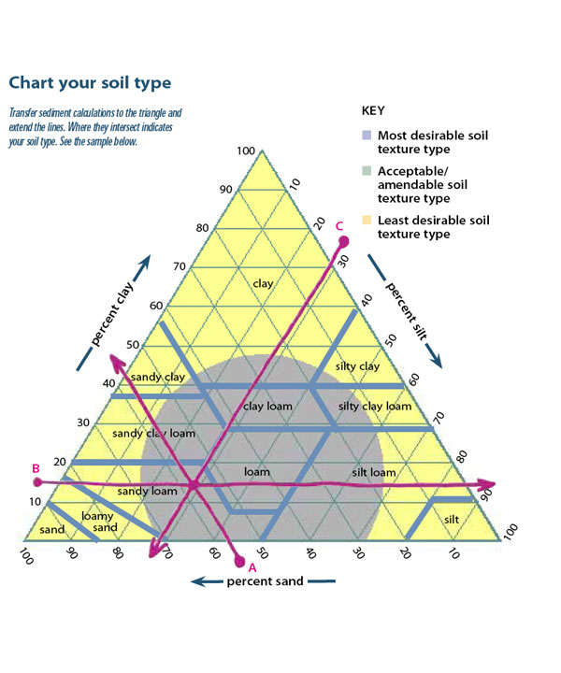
9. Identify the type of soil in the sample using the soil texture triangle pictured on the below. Each side of the triangle corresponds to one of three materials, clay, sand, and silt based on their percentages. The triangle is read by following the clay % line parallel to the triangle base, the sand line parallel to the right side of the triangle, and the silt line parallel to the left side of the triangle.

Your soil type is ________________________________________________.

10. Using the key that accompanies the texture triangle, describe your texture type: __________________________________________________________________
__________________________________________________________________
C. Measuring Porosity

Background Information
Permeability and porosity are two terms that describe the moisture content of soils. Specifically, these variables affect the water availability in soils. Permeability is the ability of water to flow through soil. Porosity describes the availability of pores to hold and transport water. Typically, the finer the texture a soil has, the lower its porosity.

Materials
- 250 ml beaker
- unknown soil sample
- known soil samples (sand, clay, silt)
- 100 ml graduated cylinder
- tap water
- calculator

Procedure
1. Fill a 250 ml beaker up to the 200 ml mark with your soil sample. Gently tamp the soil down.
2. Fill the graduated cylinder with 100 ml of tap water.
3. Slowly pour the water onto the surface of the soil until the soil is fully saturated and begins to pool on the surface.
4. Measure and record in Data Table #3 the amount of water remaining in the graduated cylinder. Determine the amount of water that was added to the soil sample by subtracting the volume of water in the graduated cylinder from 100 (initial volume).
5. Calculate the porosity of your soil sample as a percentage and record. Use the formula:

% Porosity = volume water added / 200 ml soil x 100

6. Repeat steps 1-5 for each of the pure soil samples (sand, silt, and clay)

Data Table #3: Porosity of Soils
Soil Type | Original H2O Amount in Graduate (ml) | H2O Volume Remain in  Graduate (ml) | H2O Volume Added to Soil (ml) | Porosity (%)
Unknown | 100
Sand | 100
Silt | 100
Clay | 100

Summative Assessment: Physical Properties of Soil
Name/Period: _________________________________
(#1) The jar at left is a soil sample that has had its
component parts separated into three layers.
Match the layer with the soil material by placing the letter in the blank.

_____ 1 A) clay
1
_____ 2 B) sand

_____ 3 C) silt
2

(#2) The following depth measurements were determined for each layer. Calculate the
3
total depth of the sample and the percentage that each layer occupies of the total sample.

Data Table #1: Percentages of Soil Components
Material | Sand | Silt | Clay
Depth (cm) | 3 | 4 | 1
Total Soil Depth (cm)
Percentage (%)

(#3) Use your calculations from Question
#2 above and the soil texture
triangle at right to determine which
soil type your sample is.

Soil Type = ___________________________

The following table shows some characteristics of four soil samples. Use it to answer question #4

Sample | Color | H2O Holding Capacity | % Porosity
1 | Black | Average | 50
2 | Yellow-brown | Low | 70
3 | Red-brown | Average | 60
4 | Red | Average to low | 65

(#4) _____ Soils that contain a lot of sand do not hold water very well. Which sample probably contains the most sand?
a) 1 b) 2 c) 3 d) 4

(#5) 100 ml of a soil sample has water added to it until it is saturated. The
container that the water was poured from originally had 100 ml of water in it. After pouring, 60 ml of water remains in the container. Determine the porosity of the soil?

Match the soil particle with its description.

(#6) _____ largest particle size
a) clay
b) sand
c) silt
(#7) _____ smallest pore size
(#8) _____ medium pore and particle size
(#9) _____ feels gritty
(#10)_____ feels sticky
(#11) _____ feels smooth

(#12) True or False. As particle size increases, pore size typically increases.

(#13) True or False. As porosity increases the ability for soil to hold water increases

